Project Design Phase
Solution Architecture

Date | 08 October 2026
Team ID | [Enter Team ID]
Project Name | Auto Ticket Classification using ServiceNow Flow Designer
Maximum Marks | 4 Marks

Solution Architecture:
Solution architecture is a complex process – with many sub-processes – that bridges the gap between business problems and technology solutions. Its goals are to:
- Find the best tech solution to solve existing business problems.
- Describe the structure, characteristics, behavior, and other aspects of the software to project stakeholders.
- Define features, development phases, and solution requirements.
- Provide specifications according to which the solution is defined, managed, and delivered.

Solution Architecture Diagram:

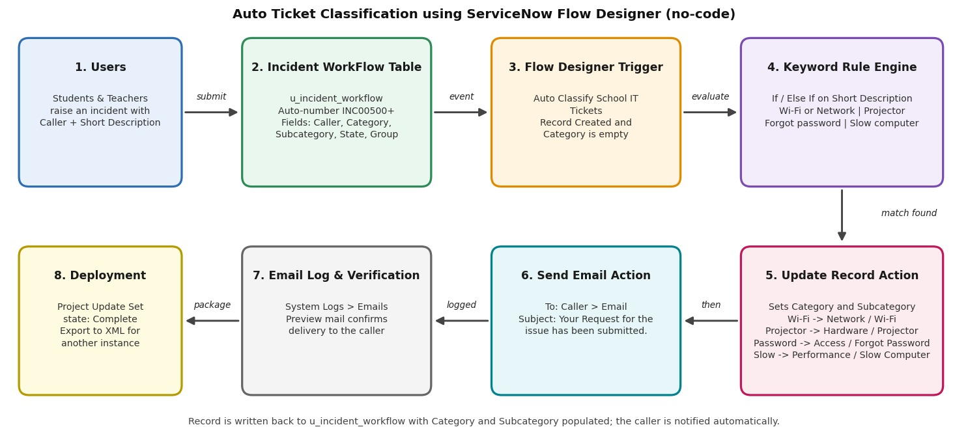
Figure 1: Architecture and data flow of the Auto Ticket Classification solution
Reference: Auto Ticket Classification using ServiceNow Flow Designer – Student Project documentation.

Architecture Components:
Layer | Component | Role in the solution
Presentation | ServiceNow form and list views | Students and teachers submit Caller and Short Description; staff view the classified ticket.
Data | Incident WorkFlow (u_incident_workflow) | Stores each ticket with an auto-generated INC number and dependent Category / Subcategory.
Automation | Flow Designer flow 'Auto Classify School IT Tickets' | Starts on record creation when Category is empty; keyword branches call Update Record.
Notification | Send Email action and System Logs > Emails | Emails the caller after classification; the email log is used to verify delivery.
Deployment | Project Update Set (Global) | Captures all configuration and is exported as XML for another instance.

Data Flow:
Step | Data flow
1 | The requester opens a new Incident WorkFlow record and enters the Caller and Short Description.
2 | On submit, the record gets its auto-number and the 'Record Created' trigger fires because Category is empty.
3 | The flow compares the Short Description with the keyword conditions in order (If, then Else If branches).
4 | The matching branch updates Category and Subcategory on the same record.
5 | The Send Email action notifies the caller, and the message is recorded in the email log.

Milestone 4: Testing, Validation and Security
The completed solution was tested end to end for data accuracy, flow behaviour and access to ticket records.
Data validation checks
- Mandatory fields are captured correctly.
- Auto-number values are generated without duplication.
- Category and Subcategory are stored correctly.
- Reference fields resolve to the required user and group records.
Security
- Access control rules were created with the table, restricting use to the role u_incident_workflow_user.
Test scenarios
Test scenario | Assigned to | Action performed | Result observed
Scenario 1: Network ticket | Dakshayani R N R | Caller selected and Short Description entered as a network issue ('My college Has issue with Network'); form saved and reloaded (INC00511). | Category = Network, Subcategory = Wi-Fi filled by the flow; email sent to the caller.
Scenario 2: Email notification check | Rubiga I | Opened All menus > System Logs > Emails, searched the subject, and used Preview mail on the record. | Two 'Your Request for the issue has been submitted.' emails listed (SMTP, send-ready); preview shows the confirmation message.
Scenario 3: Projector ticket | Harini Sri S | Caller selected and Short Description 'Projector not turning on'; form saved and reloaded (INC00512). | Category = Hardware, Subcategory = Projector; email sent to the caller.

Milestone 5: Deployment and Conclusion
Milestone 5 | Assigned to | Work completed
Activity 1: Make Update set to Complete State | Dakshayani R N R | Opened Local Update Sets, set Project Update Set from In progress to Complete, saved, and used Export to XML. The file sys_remote_update_set_a7b40de6fc590ceaad36c.xml (182 KB) downloaded and can be loaded on another instance.
Conclusion | Harini Sri S | Wrote the project conclusion and the future scope given below.

Conclusion
- The solution classifies school IT tickets from the Short Description, reducing manual categorisation and making routing consistent.
- It was delivered in phases (requirements, backend, flow automation, testing, deployment) so each step could be checked.
- The no-code design is easy to maintain; future additions are assignment automation, SLA tracking and Predictive Intelligence.

